|  |
| --- |
| SCREEN SHOT SPORTY SHOES |

LOGIN

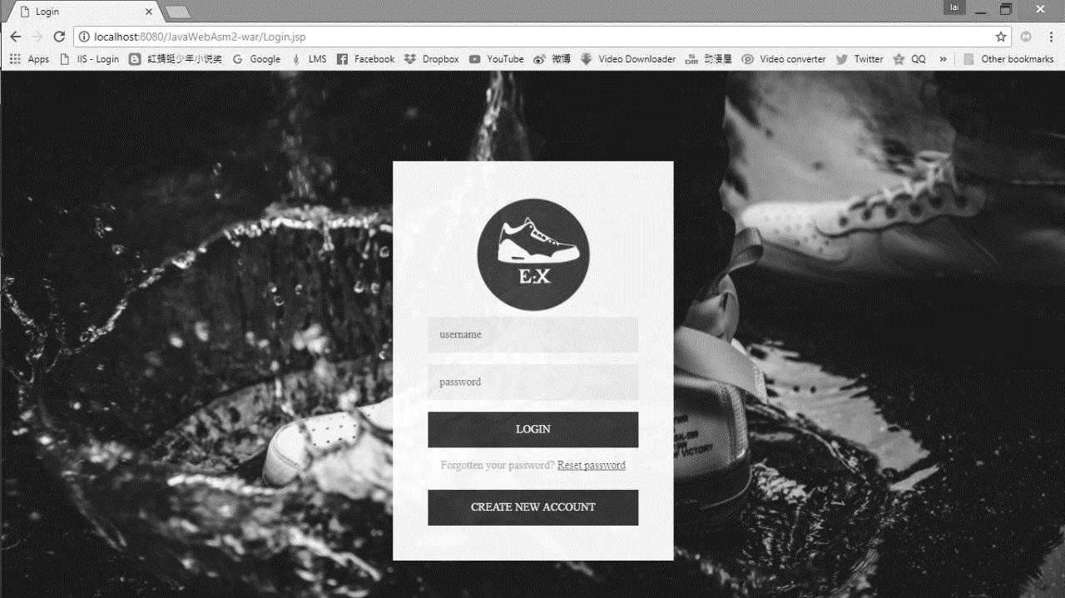

HOME PAGE

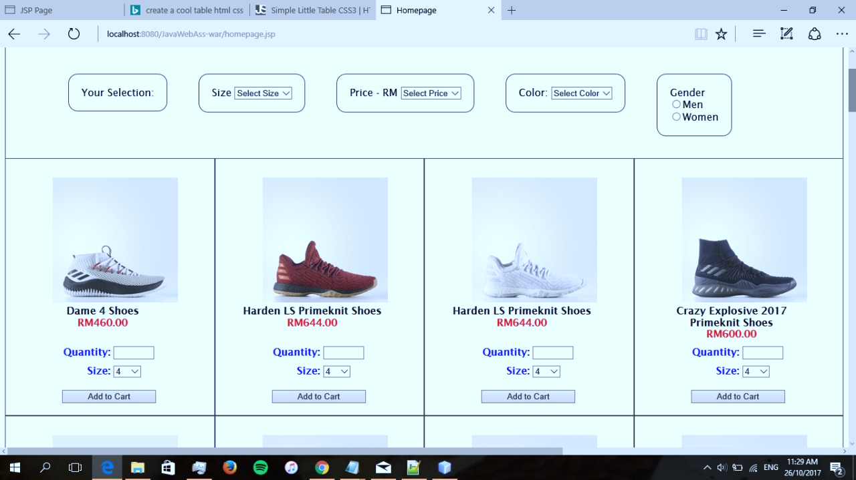

* Jsp page

